UDC
line break
Article title in English
line break
Surname N. 1
academic degree, University (city, country)
ORCID: 0000-0000-0000-0000
e-mail: email@mail.ru
line break
Surname N. 2
academic degree, University (city, country)
ORCID: 0000-0000-0000-0000
e-mail: email@mail.ru
line break
Название статьи на русском языке
line break
Фамилия И. О. 1
ученая степень, ВУЗ (город, страна)
ORCID: 0000-0000-0000-0000
e-mail: email@mail.ru
line break
Фамилия И. О. 2
ученая степень, ВУЗ (город, страна)
ORCID: 0000-0000-0000-0000
e-mail: email@mail.ru
line break
Abstract
Abstract text in English. The abstract should briefly describe the main topic, problem, objectives of the work, and research results. It must be informative, substantive, and original, without repeating the text of the article. The abstract should follow the logical structure of the results presented in the article and be concise (up to 200 words). It should provide an understanding of the essence of the research so that the reader can determine whether to refer to the full text. The key facts of the work should be presented without exaggeration and include the subject, objectives, and methods if they are not clear from the title or are of interest in terms of novelty.
line break
Keywords: keyword 1, keyword 2, keyword 3. (max 6 words)
line break
Аннотация
Текст аннотации на русском языке. Аннотация должна кратко охарактеризовать основную тему, проблему, цели работы и результаты исследования, быть информативной, содержательной и оригинальной, не повторяя текст статьи. Она должна следовать логике изложения результатов в статье и быть компактной (до 200 слов). Аннотация должна давать представление о сути исследования, чтобы читатель мог понять, стоит ли обращаться к полному тексту. Важные факты работы должны быть изложены без преувеличений и включать предмет, цели и методы, если они не очевидны из заголовка или представляют интерес с точки зрения новизны.
line break
Ключевые слова: ключевое слово 1, ключевое слово 2, ключевое слово 3. (до 6 слов)
line break
Introduction (mandatory section)
Text of the article. Text of the article. Text of the article. Text of the article. Text of the article [1]. Text of the article. Text of the article. Text of the article. Text of the article. Text of the article. Text of the article. Text of the article. Text of the article. Text of the article. Text of the article. Text of the article. Text of the article. Text of the article. Text of the article. Text of the article. Text of the article. Text of the article. Text of the article. Text of the article. Text of the article. Text of the article. Text of the article. Text of the article. Text of the article [2, 3].
Main part (mandatory section)
Text of the article. Text of the article. Text of the article. Text of the article. Text of the article [4-6]. Text of the article. Text of the article. Text of the article. Text of the article. Text of the article. Text of the article. Text of the article. Text of the article. Text of the article. Text of the article. Text of the article. Text of the article. Text of the article. Text of the article. Text of the article. Text of the article. Text of the article. Text of the article. Text of the article. Text of the article. Text of the article. Text of the article. Text of the article. Text of the article [7].
Additional Sections
Text of the article. Text of the article. Text of the article. Text of the article. Text of the article [8]. Text of the article. Text of the article. Text of the article. Text of the article. Text of the article. Text of the article. Text of the article. Text of the article. Text of the article. Text of the article. Text of the article. Text of the article. Text of the article. Text of the article. Text of the article. Text of the article. Text of the article. Text of the article. Text of the article. Text of the article. Text of the article. Text of the article. Text of the article. Text of the article. Text of the article. Text of the article. Text of the article. Text of the article (table 1).
Table 1
Table title
Alignment: Center  Font: 12 pt, Bold | Alignment: Center  Font: 12 pt, Bold | Alignment: Center  Font: 12 pt, Bold
Font: 12 pt, Regular | Indent: 0 cm | Alignment: Justified
Font: 12 pt, Regular | Indent: 0 cm | Alignment: Justified
Font: 12 pt, Regular | Indent: 0 cm | Alignment: Justified
Text of the article. Text of the article. Text of the article. Text of the article. Text of the article. Text of the article. Text of the article. Text of the article. Text of the article. Text of the article. Text of the article. Text of the article. Text of the article. Text of the article. Text of the article. Text of the article. Text of the article. Text of the article [9]. Text of the article. Text of the article. Text of the article. Text of the article. Text of the article. Text of the article. Text of the article. Text of the article. Text of the article. Text of the article. Text of the article (fig. 1).
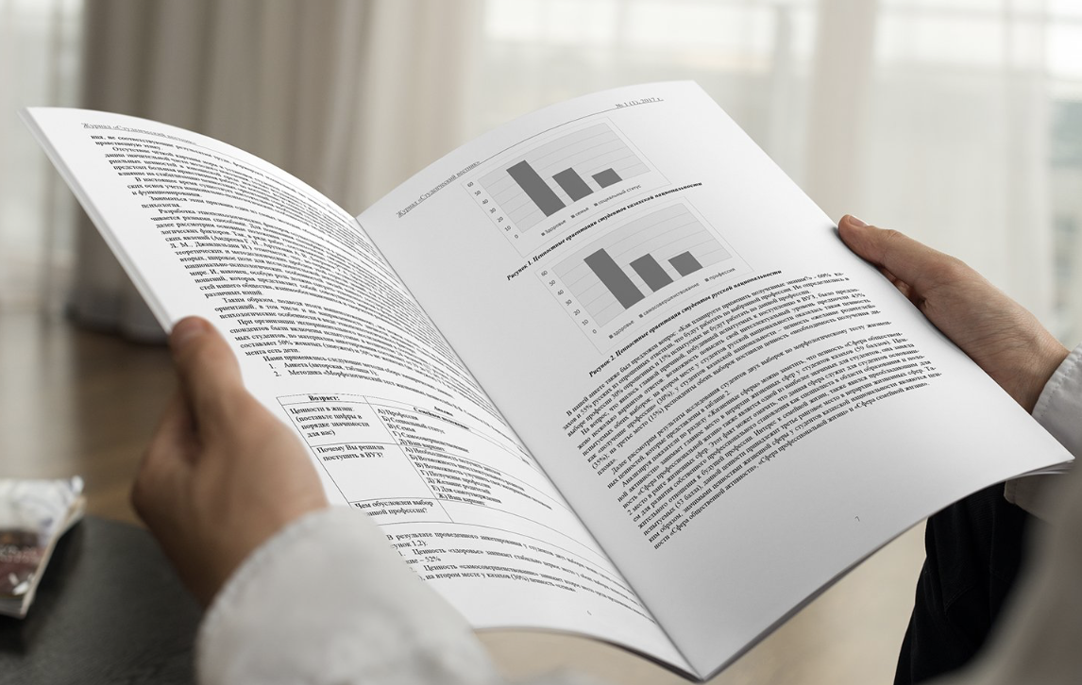
Figure 1. Figure title
Text of the article. Text of the article. Text of the article. Text of the article. Text of the article. Text of the article. Text of the article. Text of the article. Text of the article. Text of the article. Text of the article. Text of the article. Text of the article. Text of the article. Text of the article. Text of the article. Text of the article. Text of the article [10-12]. Text of the article. Text of the article. Text of the article. Text of the article. Text of the article. Text of the article. Text of the article. Text of the article. Text of the article. Text of the article. Text of the article. Text of the article. Text of the article. Text of the article. Text of the article. Text of the article. Text of the article. Text of the article. Text of the article. Text of the article. Text of the article. Text of the article. Text of the article.
Text of the article. Text of the article. Text of the article. Text of the article. Text of the article. Text of the article. Text of the article. Text of the article. Text of the article. Text of the article. Text of the article. Text of the article. Text of the article. Text of the article. Text of the article. Text of the article. Text of the article. Text of the article. Text of the article. Text of the article. Text of the article.
$Formula (centered, indent: 0 cm)$ (1)
Text of the article. Text of the article. Text of the article. Text of the article. Text of the article. Text of the article. Text of the article. Text of the article [13]. Text of the article. Text of the article. Text of the article. Text of the article. Text of the article. Text of the article. Text of the article. Text of the article. Text of the article. Text of the article. Text of the article. Text of the article. Text of the article.
Conclusion (mandatory section)
Text of the article. Text of the article. Text of the article. Text of the article. Text of the article. Text of the article. Text of the article. Text of the article. Text of the article. Text of the article. Text of the article. Text of the article. Text of the article. Text of the article. Text of the article. Text of the article. Text of the article. Text of the article. Text of the article. Text of the article. Text of the article. Text of the article. Text of the article. Text of the article. Text of the article. Text of the article. Text of the article. Text of the article. Text of the article. Text of the article. Text of the article. Text of the article. Text of the article. Text of the article. Text of the article. Text of the article. Text of the article. Text of the article. Text of the article. Text of the article. Text of the article. Text of the article. Text of the article. Text of the article. Text of the article. Text of the article. Text of the article.
References:
(formatted according to GOST R 7.0.100-2018 "Bibliographic Record")
- Source 1.
- Source 2.
- Source 3.
- Source 4.
- Source 5.
- Source 6.
- Source 7.
- Source 8.
- Source 9.
- Source 10.
- Source 11.
- Source 12.
- Source 13.

